**Computed Density Calibration view (TR+SM+JW)**

**Initial view**

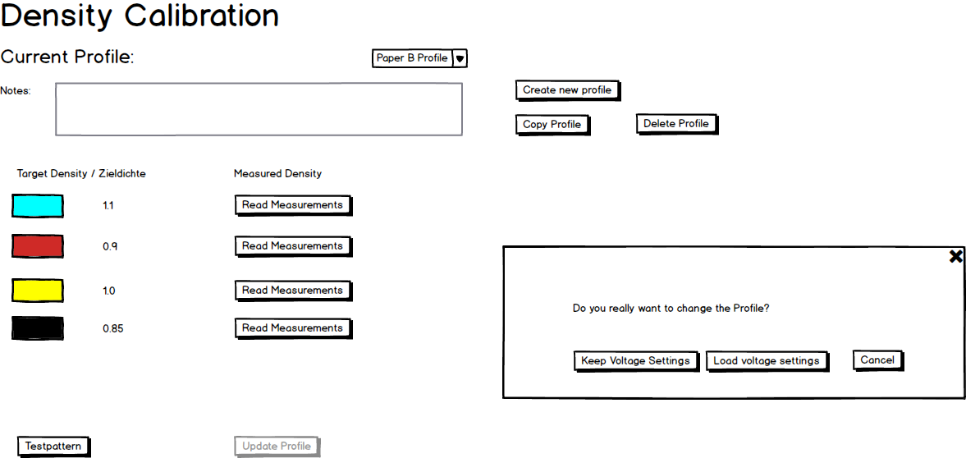

**Create new profile at first time**

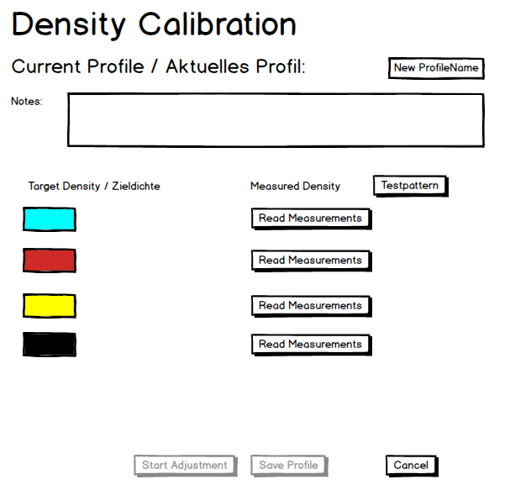

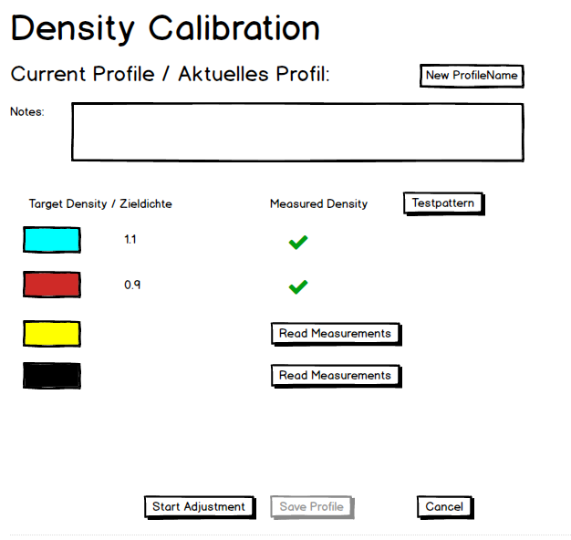

**Copy Profile: copy an existing profile and create a new profile with a new name.**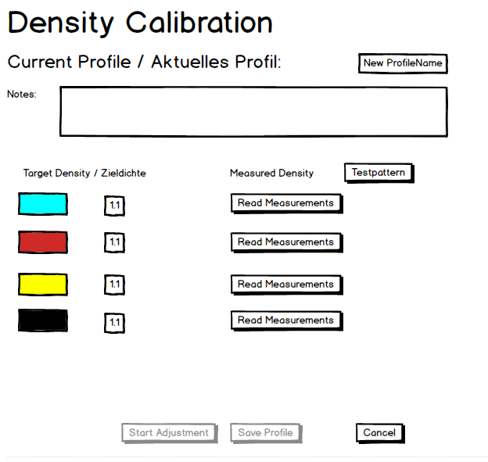

**Read measurements and start Adjustments**

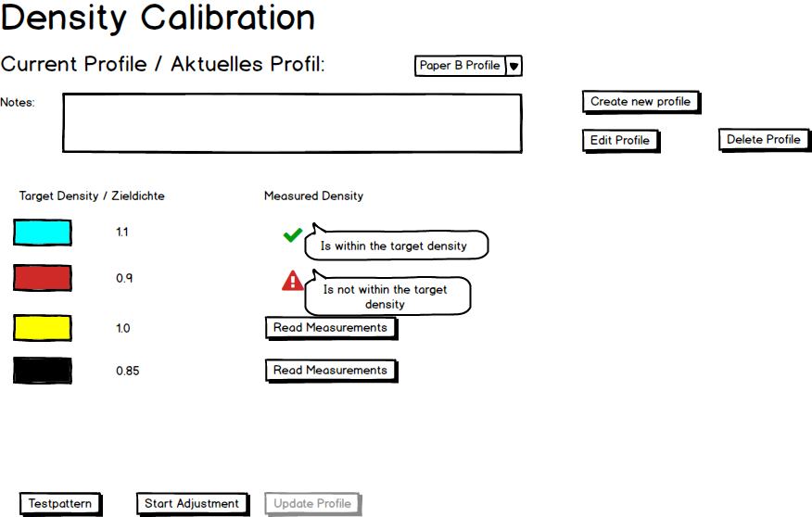

**Update voltages to Print heads**

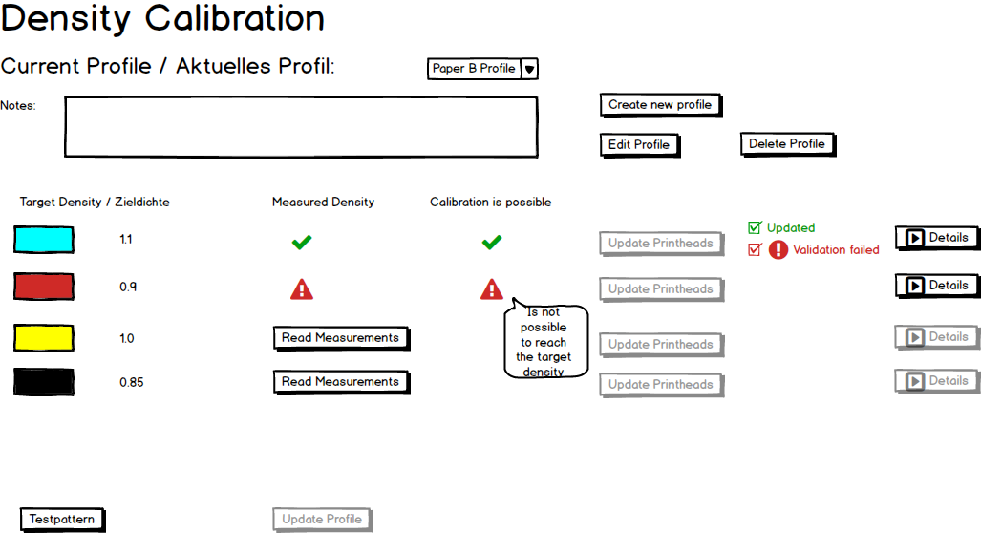

**Details of Not applied details**

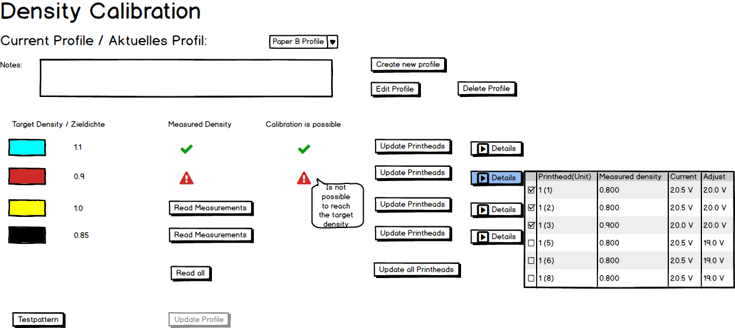

Redo the Read measurements, adjustment and update voltages to print heads until its reach the target density.

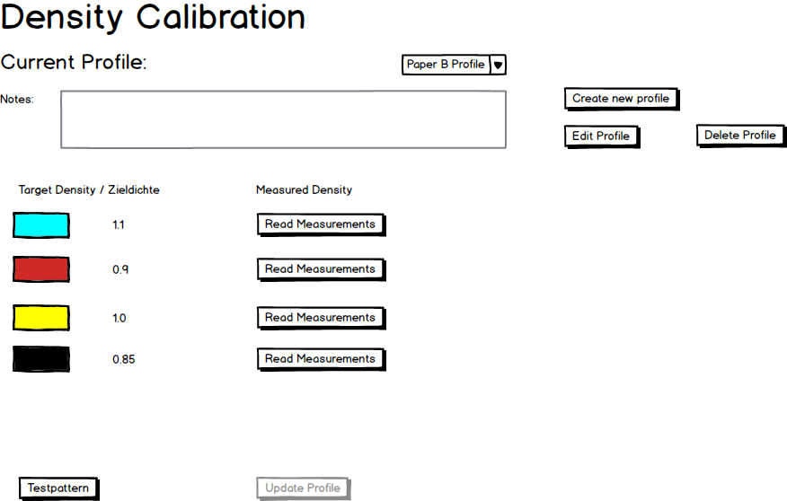

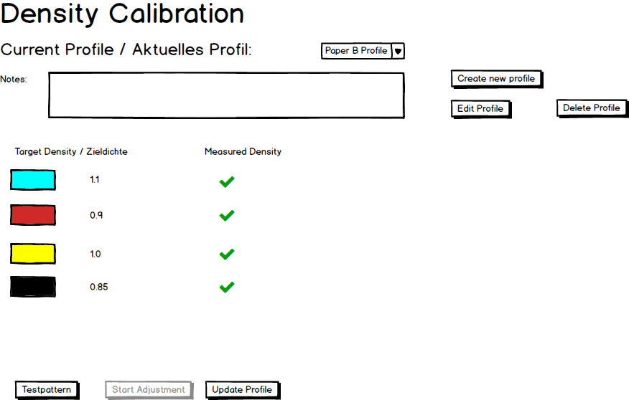

Finally update the profile, which will take all measurements and save it into the database.

**Workflow diagram: Create profile**



**Workflow diagram: copy profile**



**Workflow diagram: load profile**



Mapping between the View and Density Calibrator

**Read Density Measurements**

* Select the file and get the measurement of Cyan from CSV.
* Select the file and get the measurement of Red from CSV
* Select the file and get the measurement of Yellow from CSV
* Select the file and get the measurement of Black from CSV

**Start Adjustment**

* Take all the measurement and call the Calculate Print head voltages.

**Update Print heads**

* Check it’s possible to write into the print heads, if no inform to user about it
* Take an input of Calculation result and Update the voltage (Write to print heads)

**Details**

* Display only if any PCC's are not possible to calibrate. (Get it from Density Calculation Details (Currently are displaying via Message box))

**Test Pattern**

* Call test pattern using client

**Update profile**

* Call context and store the profile along with voltage state

***Read All***

* Read all measurements for all colors from CSV

***Calibrate All***

* Calibrate for all colors.

**Create profile**

* Read the measurements from the csv file and get the average target density of each color and create it
* Note: It won’t save into the database in this moment, save the profile once the calibration is successfully done.

**Copy profile**

* Copy the existing profile (change the target density if we want) and decide whether we apply the unit voltages or keep the current voltage settings.
* Note: It won’t save into the database in this moment, save the profile once the calibration is successfully done.

**Edit Profile**

* Possible to change the notes (we should not allow to change the target density, if you want to change go for create new profile)

**Delete Profile**

* Delete the currently selected profile. (soft delete)

**Missing implementation points**

* Calculate average target density of each color.
* Create and save the new profile.
* Edit the existing profile.
* Delete the existing profile.
* Update profile
* Load profile
* View
* View Model.

**Work item1:** Create View according to the screen shot in one user control

* View

**Work item2:** Create view model according to the screen shot.

* View Model.

**Work item3:** Bind View and View Model.

**Work item4:** Adjust “the basic function of density calibration” regarding the workflow of “Density Profiles” (Receive the measurement values for only one color):

* Calculate average target density of each color.

**Work item5:** Use the database context to perform the CRUD operation

* Create new profile.
* Edit the existing profile.
* Delete the existing profile.
* Update profile
* Load profile

**Work item6:** Show and Hide the feature according the action (NTD)

For ex:

* + - Displayed in Mockup
    - If we don't have any profile currently, Create New Profile section will be displayed.
    - After measurement reading only allow to start the adjustments.
    - After adjustment only allow to update into the print heads.
    - After updating the new voltages only allow to see details in case of validation failed.
    - …

**Work item7:** Review

**Work item8:** integration test.